|  |  |
| --- | --- |
| **Course: WEB TECHNOLOGIES**  **Worksheet #1**  **MOHIT RANA**  **20BCS1156** | |
|
| **Sr. No.** | **Topics Covered** |
| 1 | Introduction to HTML, Minimal document structure, Type declaration |
| 2 | Header elements, text and formatting tags, links |
| 3 | Images and objects, Linking of web pages. |
| 4 | list and generated content |
|  |  |
| **Sr. No.** | **Implementation using various HTML Tags in Notepad** |
| **1** | Create a webpage which should have Title as defined by user. it should display content in bold, itallics, underlined and entire content should be center aligned. Include the link to www.google.com also. |
| **2** | Create a HTML Document in such a way that it should include the tags like paragraph, h1 to h6 heading, break tag usage. |
| **3** | Create a webpage which should have an image as background with width 400px and 500px dimensions. If the image could not be loaded, it should display an alternate text which should inform the user about the same. |
| **4** | Insert an image and create a link such that clicking on image takes user to other page. |
| **5** | Create an ordered list which should display the grocery items to be purchased by a household. Include the miscellaneous items also in the least priority list using unordered list.CSS list-style-type property should also be included. |
| **6** | Create a webpage that prints your name to the screen, print your name in  Tahoma font, print a definition list with 5 items, Create links to five different pages, etc. |

1. **Create a webpage which should have Title as defined by user. it should display content in bold, itallics, underlined and entire content should be center aligned. Include the link to www.google.com also.**

**CODE -**

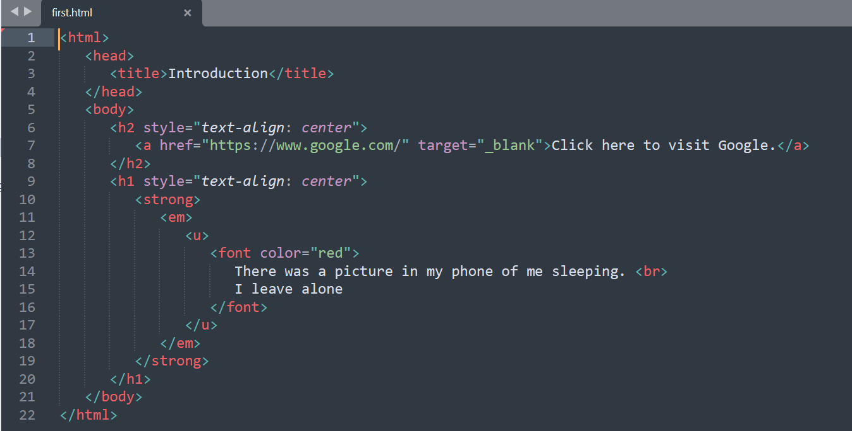

**OUTPUT -**

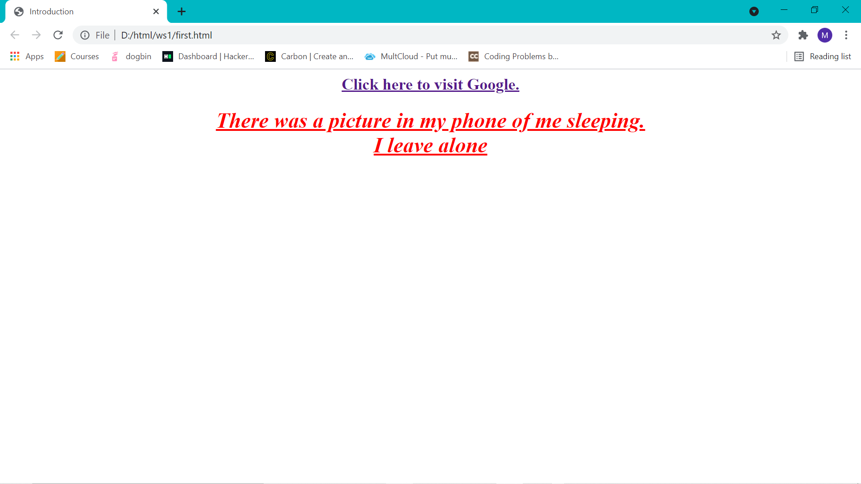

1. **Create a HTML Document in such a way that it should include the tags like paragraph, h1 to h6 heading, break tag usage.**

**CODE -**

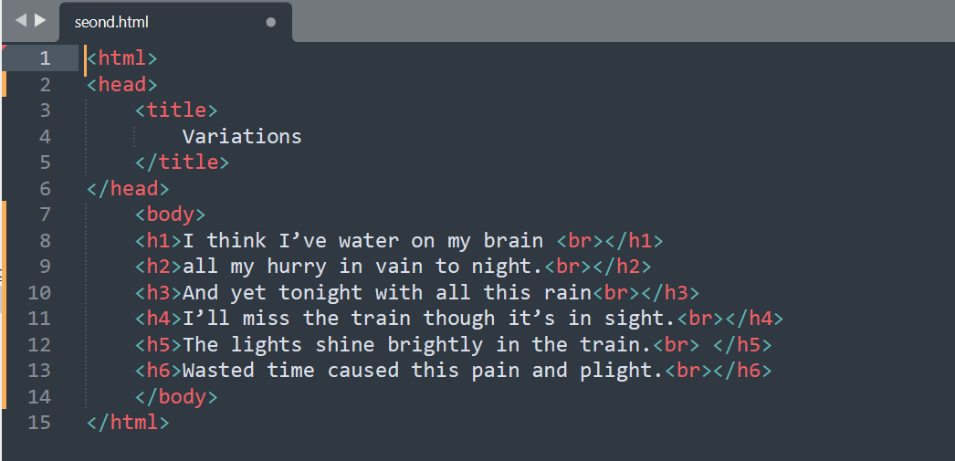

**OUTPUT -**

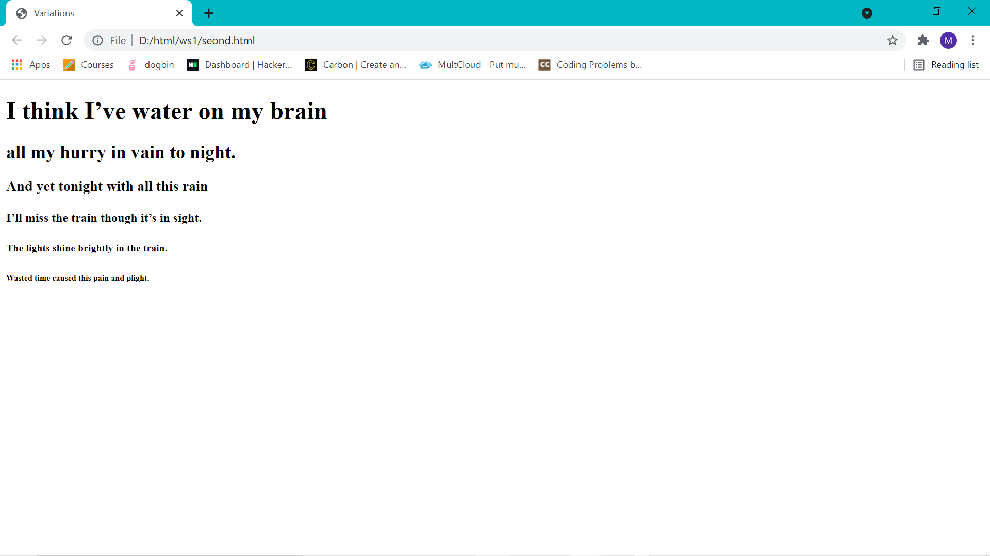

1. **Create a webpage which should have an image as background with width 400px and 500px dimensions. If the image could not be loaded, it should display an alternate text which should inform the user about the same.**

**CODE -**

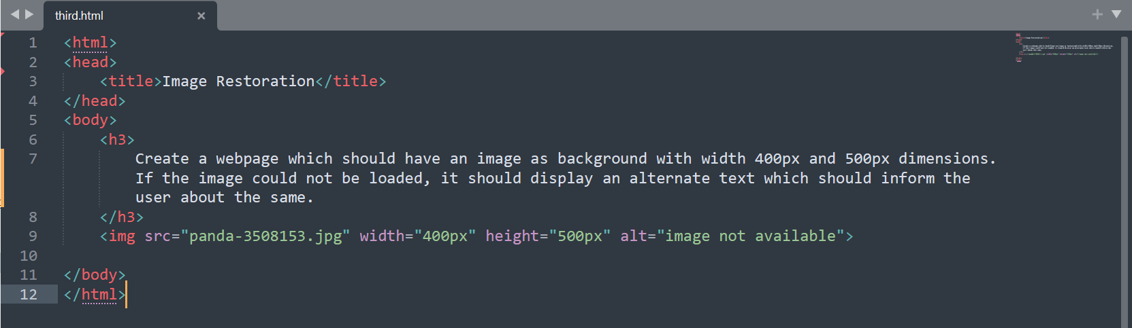

**OUTPUT –**

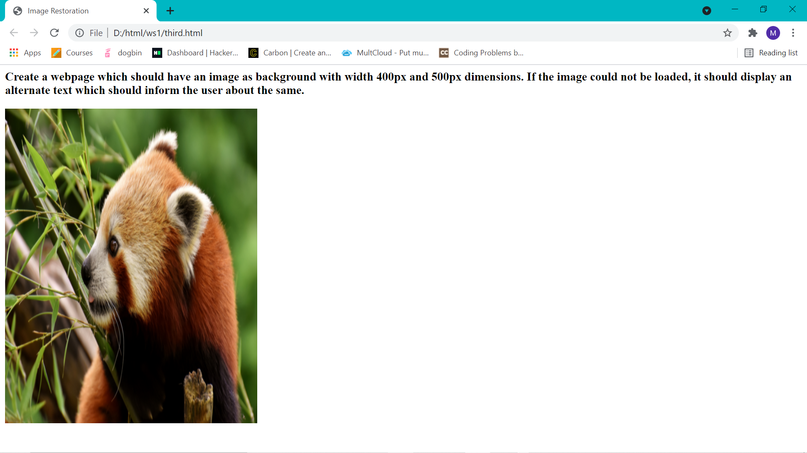

|  |
| --- |
|  |

1. **Insert an image and create a link such that clicking on image takes user to other page.**

**CODE -**

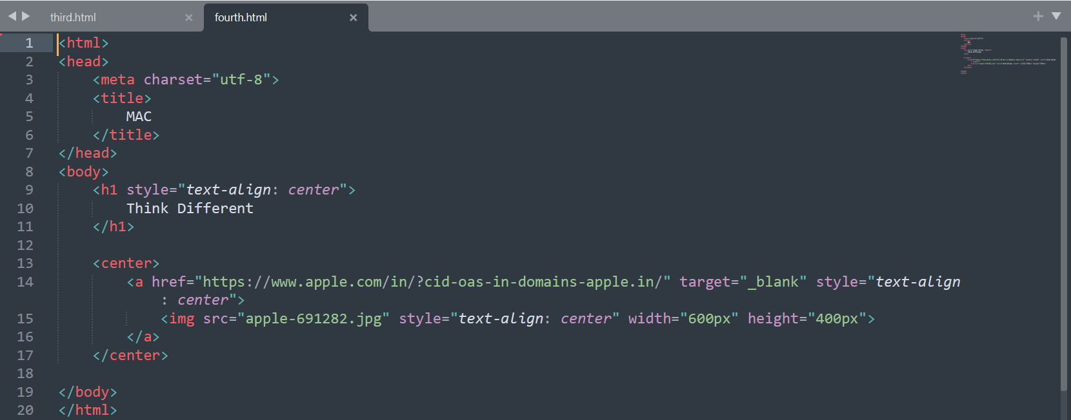

**OUTPUT -**

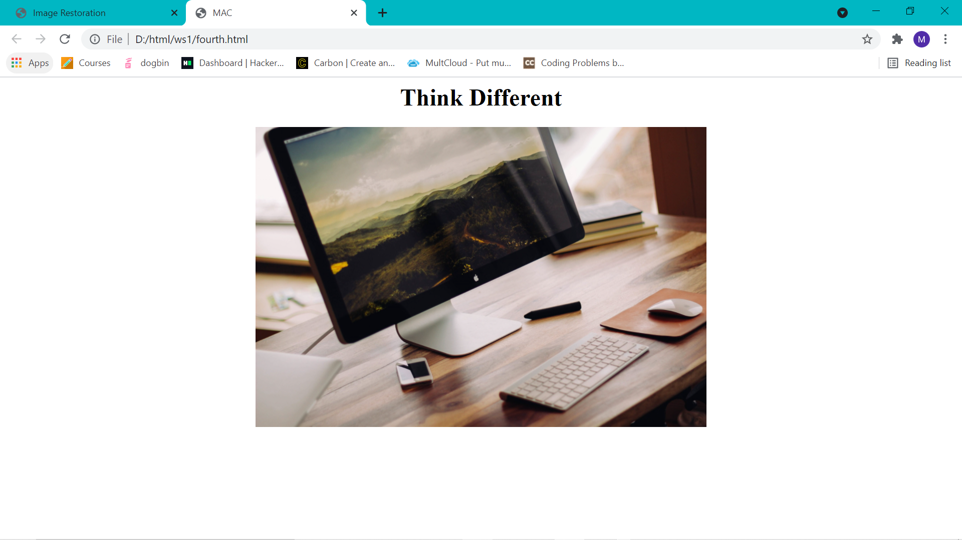

1. **Create an ordered list which should display the grocery items to be purchased by a household. Include the miscellaneous items also in the least priority list using unordered list.CSS list-style-type property should also be included.**

CODE -

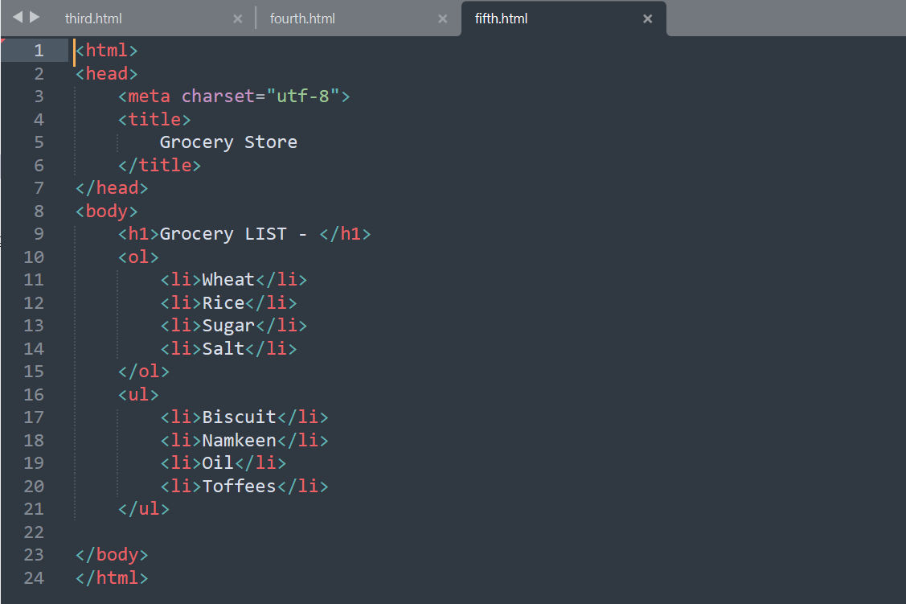

**OUTPUT -**

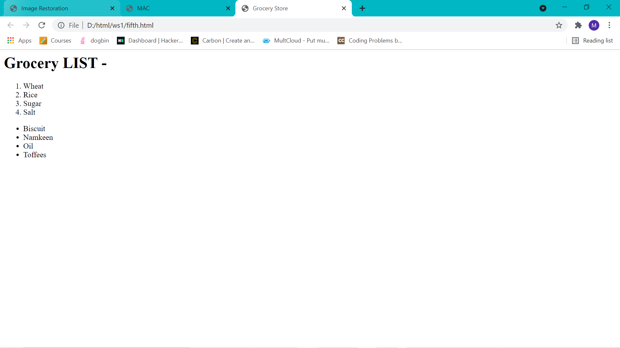

1. **Create a webpage that prints your name to the screen, print your name in  Tahoma font, print a definition list with 5 items, Create links to five different pages, etc.**
2. **CODE**

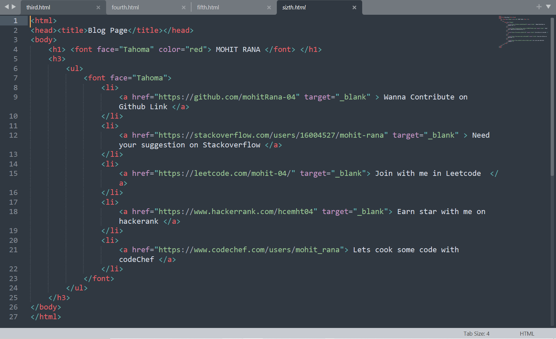

**OUTPUT –**

